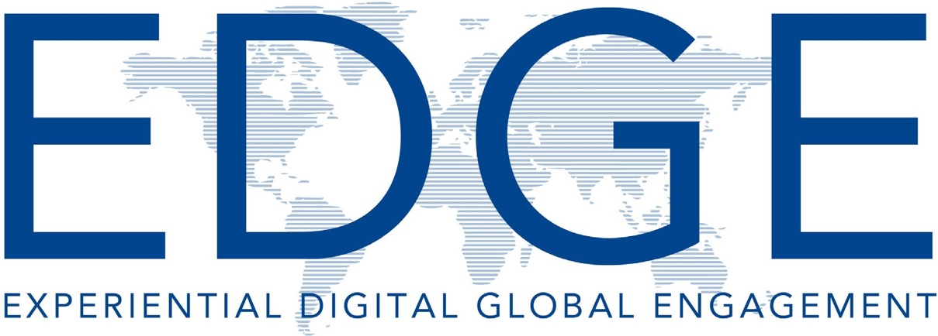

Guidebook

Pennsylvania State University EDGE Program

The information provided in this guide holds much of what you need to embark on a journey of global teaching. Be aware that each EDGE course is unique and requires unique considera- tion. However, equipped with this information you will be ready to move forward to begin the design and development of your EDGE course. Keep in mind that flexibility, patience, and open communication between partners are key factors in the success of EDGE courses.

Acknowledgements
The EDGE Guidebook committee members want to thank Dr. Jenifer Cushman, Chancellor

of Penn State Beaver, for recognizing the value of bringing global partnerships in the form of EDGE to Pennsylvania State University and the Commonwealth campuses. Her vision and de- termination to build this program has provided many students and faculty with experiences in global learning and a variety of collaborative projects that have built friendships, partnerships, and networking across many countries.

EDGE Guidebook Committee members
Samantha Beebe, Program Coordinator , Biobehavioral Health Lecturer, Lehigh Valley
Marilyn Goodrich, Instructional Designer, TLT/Shared Programs, University Park
Tiffany MacQuarrie, Professor in Charge of EDGE and Assistant Teaching Professor of English, Beaver
Kate Morgan, Director, Instructional Design and Virtual Learning, Lehigh Valley
Daniel W. Smith, Associate Teaching Professor, Business, Beaver

Summer 2020

Table of Contents
A Word from the Professor In Charge 1
What is Experiential Digital Global Engagement? 2
How Does an EDGE Course Differ from....Course? 2
What is Specific to the EDGE Course Model? 2
Module 1: Launching EDGE 3-6
Step 1: Finding an International Partner 4
Step 2: Identify a Course to Be EDGEd 5
Modules 1 Notes 6
Module 2: Developing a Sustaining Partnership 7-11
Selecting a Partner 8
Negotiating with Your International Partner 8-9
Module 2 Notes 11
Module 3: Developing and Delivering Your Collaborative Project 12-17
EDGE Learning Outcomes 13
Global Learning Rubric 13-14
Importance of Student Collaboration vs. Shared Project 15
Deliverables and Grading 15
Course Module and Lesson Development 15
Provide Opportunity for Critical Reflection/Assessment 15
Technology 16
Expect the Unexpected 16
Module 3 Notes 17
Module 4: Preparing Students for EDGE Collaboration 18-22
Developing Intercultural Competence 19
Cultural Competency 19-20
Story from the Field with Claudia Tanaskovic 20
Formulate Relationships Using Icebreakers 20
Story from the Field with Tiffany MacQuarrie 21
Gaining Student Buy-in 22
Story from the Field with Dan Smith 22
Module 4 Notes 23
EDGE Resources 24

A Word from the Professor in Charge of EDGE
Greetings! Thank you for committing to learn more about our EDGE (Experiential Digital Global Engagement) program. This guide is designed to come alongside you wherever you are in your EDGE journey: finding an international partner, determining which course to EDGE, developing your learning objectives, designing a collaborative project, identifying technology to sup- port your collaboration, creating or identifying assessment tools, and preparing your students for the EDGE experience. The body of the guide provides the essential information organized to complement each of the training modules.

EDGE is unique in that travel is NOT a required component. Faculty are encouraged (as much as time and resources allow) to travel to meet their international partner and tour the University or Institute and surrounding region; however, faculty can deliver their EDGE courses and develop meaningful and sustaining partnerships through remote meetings only. Similarly, we recommend that you consider planning embedded study abroad trips for your students to meet their international partners
during spring break or summer, but again, it is not required. Because travel is not required for EDGE, the program provides the
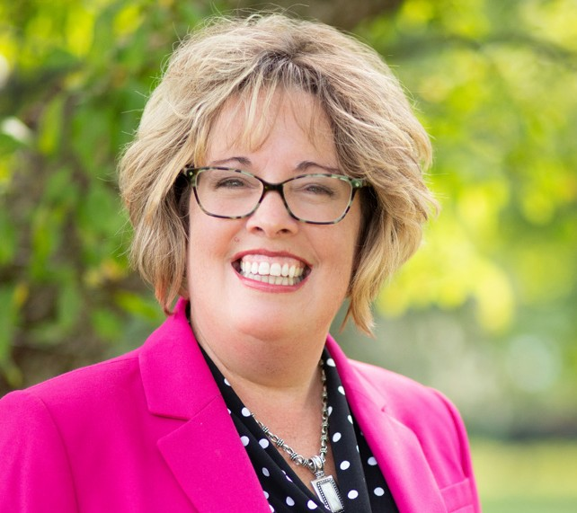
opportunity to engage in global learning for ALL Penn State students.

We look forward to your involvement in EDGE. Thank you for investing in this valuable opportunity to increase our students’ global awareness, global literacy, global compe- tency, intercultural competency, and global citizenship.

Best,
Tiffany MacQuarrie Professor in Charge of EDGE

Penn State believes that transformative academic experiences and high-impact practices are imperative to cultivating a di- verse and inclusive environment and preparing students for the twenty-first century workforce. EDGE connects Penn State classes with classes around the world through the use of technology. A type of project-based international virtual exchange, EDGE affords its participants, particularly place-bound and lesser-resourced students, the opportunity for global thinking and collaboration.

Participating students are guided to engage with the larger world by deepening their understanding of themselves, their cul- ture, their perception BY “others,” and their perception OF “others.” These globally networked courses intensify disciplinary learning in all fields, both in those which engage other cultural perspectives and fields less traditionally associated with global learning. EDGE seeks to build bridges among international partners, instructional design, and teaching faculty through courses linked by a collaborative project, thereby promoting, integrating and enhancing international education experiences across curricula.

Mission
To encourage and support the development and implementation of globally-networked, project-based courses to

foster experiential, cross-cultural learning.

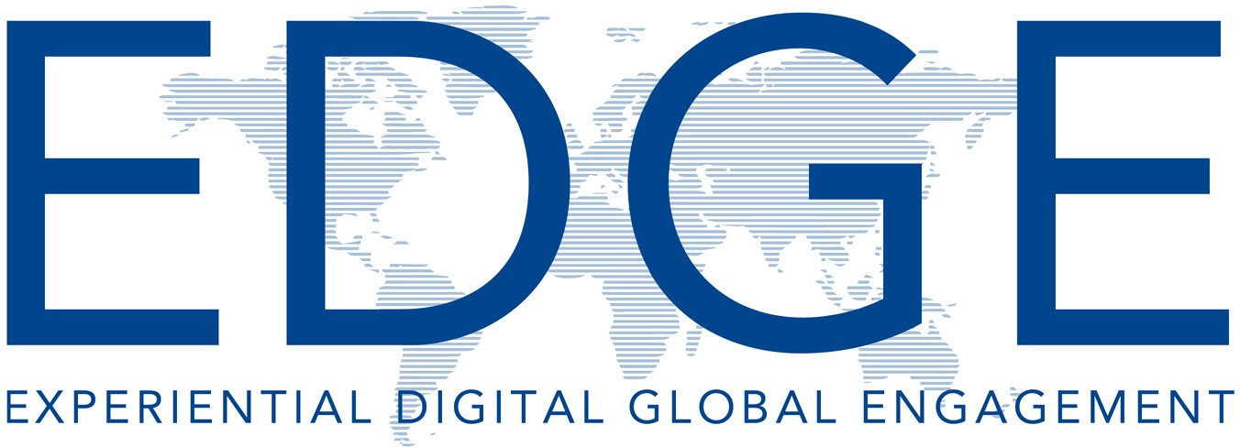

What Is Experiential Digital Global Engagement?
EDGE, a subset of what is commonly referred to as globally networked learning and international virtual exchange, is
a project-based teaching and learning approach that pro- motes the development of intercultural competence across shared multicultural learning environments through the use of Internet-based tools and innovative online pedagogies. EDGE fosters meaningful exchanges between instructors and students with peers in geographically distant locations and from different lingua-cultural backgrounds.

EDGE courses, which link a class at Penn State with one abroad through a collaborative project, are co-equal and linked by instructional partners who collaborate to develop a shared course module that emphasizes experiential and collaborative student-centered learning. It is not a shared course; it is a shared module containing a collaborative project. While the international component of the course takes place solely online, the individual courses may be fully online or, more often, are offered in blended formats with traditional face-to-face sessions taking place at both schools.

How Does an EDGE Course Differ from an On- line or Distance Learning Course?
An EDGE course is specifically designed to link students who have different cultural and geophysical perspectives and experiences. A typical online course may include stu- dents from different parts of the world; however, an EDGE course engages students in learning course content both through their own unique cultural lens and also by exchang- ing their cultural and experiential lenses as they complete
a collaborative project. By helping students to reflect with each other, you and your partner instructor will be facilitat- ing a cross-cultural dialogue that brings a global dimension to your course content.

What Is Specific to the EDGE Course Model?
EDGE courses emphasize the collaborative process be- tween both teachers and students. While podcasts, webi- nars and video-streaming may be ways to reach an interna- tional audience, we believe that it is the actual negotiation of meaning from the creation of the shared module between teachers, through the use of social media, to the develop- ment of collaborative project work between students where the stakes are raised as participants work to create shared experiences and understanding. By committing to a bi-di- rectional process which is often multi-lingual, cross-cultural discoveries are made and these courses begin to model rel- ativistic, less hegemonic approaches to meaning and truth.

Another important aspect of EDGE courses is that they aim to exploit the multimodal potential of online communication. Although they do not allow collaborating students to meet over coffee, through social media partners can still engage in informal communication with their distant peers in much the same way as they do with their local peers using social media tools such as Facebook or messaging apps such as What’s App.

Finally, EDGE is different from other models of globally networked learning in that it offers neither a platform nor a specific set of tasks and activities. Each EDGE course is
as unique as the course content, the individual institutional resources and support, the country context, and the rela- tionship between the partners.

Launching EDGE
Module 1

After making the decision to participate in EDGE, launching EDGE involves two steps:

- Find an International Partner, if you do not already have one
- Determine which course you will EDGE.

Step 1: Find an International Partner
The first step is to find an international partner.

Do You Have a Partner with Whom to Work?
Locating the right partner can be the most challenging aspect of your design process because having the right partner can literally make or break your EDGE course. As in developing any type of close working relationship, you need to find a good fit where there is an alignment of goals and a sense
of trust, but in this case you are adding the complexity of crossing cultures, which may demand real sensitivity on both sides. If you have already established a working relationship with teachers from other international institutions, you may want to draw upon that established relationship for an EDGE course.

If you already have a partner, then you can go directly to Module 3: Developing and Delivering Your Collaborative Proj- ect on page 12.

If You Don’t Have a Partner, Where Can You Locate One?
A 2012* survey of European practitioners engaging in EDGE- type activities found that two-thirds of respondents found their partner through their own network of colleagues and collaborators, and the remaining third through colleagues they had met at professional conferences, through their institution’s network of partner institutions and/or through partner-finding websites and/or social networks.
*In Moore, A. S., & In Simon, S. (2015). Globally networked teaching in the humanities: Theories and practices.
4
The list of Penn State’s EDGE partnerships continues to grow each year. If you find yourself in the remaining third (using institution’s network), here is what you can do to find an international partner:

- Review the most recent list of EDGE-partnered institu- tions found on our EDGE website.
- Talk with the EDGE coordinator at your campus location.
- Contact the Professor in Charge to see what institutions are seeking additional partners. (This information is also shared at the monthly EDGE meetings during the fall and spring semesters.)
- Explore Penn State’s Global Programs’ list of institution- al partners.

Next, discuss the idea of EDGEing a course with your Direc- tor of Academic Affairs (DAA) and then continue to update him/her throughout the collaboration.

Once you have a partner institution in mind and you have spoken to your DAA, contact the Professor in Charge so that introductions may be made.

As you begin your search for an international partner, consid- er these key questions:

- What geographic global perspective(s), if any, would best suit your course content?
- Do you have colleagues in that part (or those parts) of the world? Do any of your colleagues?
- Does your college have a partnership with an institution in that part of the world from which you can draw?
- Are there academic communities or disciplinary asso- ciations that could help you connect with a colleague? Do they have listservs or other portals through which members can communicate directly with each other? If so, you may consider directly posting a clear description of what you want to do, while stating the key goals of your course and the value of the proposed academic collaboration.

Step 2: Identify a Course to Be EDGEd
Both you and your international part- ner should share with one another the content and assignments of the cours- es you teach. Then brainstorm which courses might best lend themselves
to developing a collaborative project. Think of common, complimentary, or relatable themes present in the two courses. Look for points of intersec- tion.

What Qualities Make a Course a Good Candidate for an Experiential Digital Global Engagement Experience?
There are very few courses which cannot be adapted to the EDGE model; however, it may not always be obvi- ous what specific qualities within the course make it a good candidate. Here are a few reflective questions that you can ask yourself to help determine how EDGE could help enhance the de- livery of your course content and your students’ learning experience:

- Which components of your course would be enhanced if students could discuss their implications with peers in another geo-loca- tion?
- Which components of your course might be de-emphasized and which could be more foreground- ed to encourage time for exten- sive discussion and collaboration?
- How would having multiple or different cultural perspectives enhance your students’ under- standing of the course content and energize your classroom?
- Are there projects that the two student cohorts could develop to- gether or are there photos, videos or other course-related artifacts that students could exchange and discuss cross-culturally?
Please remember that EDGE courses do not need to be paired with courses from the same discipline. EDGE cours- es have great inter-disciplinary AND intra-disciplinary potential.

Are You Ready to Teach Your Course in a Technologically Enhanced Way?
Regardless of the tools you choose, there is a minimum level of comfort you should have with technology before embarking on an EDGE course. The good news is that you and your partner will first determine learning goals; the technology tools come later. Also, you and your partners are in control of the tools that you use. If you are only com- fortable with one or two technologies, such as email and Skype, then design your course within those boundaries.
If you or your partner’s university has a learning management system (LMS)
such as Canvas, Blackboard, or Moodle and access can be shared, then you can build your course on that platform. If you want to explore other technological tools, then that is another avenue to consider. The real point is that you both should feel comfortable enough with the technology before the class starts to facilitate the technology gradually “fading into the background” so you, your partner, and both sets of students can focus on the course content and on their exchange. In a similar way, you’ll usually have to allow some time and possible training at the beginning of the EDGE course for the students to be- come familiar with the tools used. (You may even consider assigning an ice- breaker activity that will allow students to experiment with the technology in a low-stakes assignment.)

If you are basing your collaboration on courses that are already fully online, you will probably want to stay with that for- mat. However, if you or your partner has been teaching in a traditional classroom setting, you have a few options:
- overlay your usual face-to-face sessions with the online collaborative component that you are now developing
- replace some of the usual classroom meetings with online ses- sions.

5
This type of combined class format is called a blended or hybrid learning model, and when well-executed com- bines the best of both worlds.

Do You and Your Partner Have the Support of Your Institution?
In institutional settings, while there may be some flexibility regarding course content, there may also be boundaries that limit curricular chang- es. Fortunately, EDGE courses can be considered a means to internationalize your curriculum, so you may be able to gather support centrally from adminis- tration to accommodate course altera- tions. The key point is that the course content is not about to dramatically change, but rather your delivery of the content is about to be potentially en- hanced with an international or global component. You should be aware that administrative support can be vital to receiving technological and teaching resources as well as providing teachers time to design, develop and deliver the course so every effort should be made to get an institutional commitment to the developmental process.

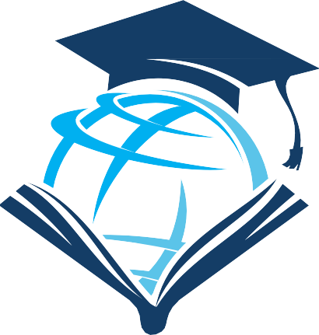

Notes

Developing a Sustaining Partnership

Module 2

Because of the work that it takes to develop and deliver an EDGE course, our hope is that partnered faculty will continue to work together in future semesters. Just as it takes several iterations of the same course to learn how to tweak the course content and delivery to find the most effective combination, the same is true for the EDGE collaboration. Delivering the EDGE content in the same course with the same international partner will provide opportunity to fine-tune the project.

When Seeking a Partner, What Are Some of the Key Criteria for Their Selection?

Equal Commitment
Both you and your partner need to be relatively equally en- gaged, committed and responsive to negotiating the course content and teaching load that you will be sharing. Without equal input the course can become unbalanced and will only reflect one cultural perspective. This can undermine the most valuable aspect of the course as you and your partner should ideally be modelling productive cross-border collaboration to your students. Understandably, this can be challenging because most initial partnered relationships,
especially across international borders, are never completely equitable. Nevertheless, this should be a goal.

Shared Global Learning Objectives
The starting point for these discussions is often an existing course syllabus, but it can be useful to step back from this foundational document to discuss each teacher’s global learning objectives (See AAC&U’s Global VALUES rubric shown on page 14) for the course and for the cross-cultural exchange. Once global learning objectives have been iden- tified, teachers can then create a collaborative project that will help students meet the global learning objectives in their EDGE course.
Differences in Institutional Cultures
In many countries and at many institutions, professors are not expected to propose major structural changes to the way their course is taught. Modifying their class assignments may require authorization from a supervisor. Additionally, proposing to work in partnership with a colleague in another country may require the direct involvement of a senior ad- ministrator. In the early stages of planning an EDGE project, it is important to discuss openly the institutional cultures and hierarchies that may need to be navigated if there is to be a successful outcome of the collaboration.

Open Mindset
The aim is usually not to find an exact copy of your existing course in another cultural context or even to find a course in your discipline, but to look for ways another teacher’s materi- al, approach, or discipline might enrich your existing course. The more open-minded both partners are and the more flexi- ble they are, the better the end product is likely to be.

Negotiating with Your International Partner
Once you have found a partner and determined that you both have the commitment and institutional support needed to embark on the development of an EDGE course, the next step is to begin your negotiation.

# 1: Arrange a Face-to-Face Meeting with Your Faculty Partner, If Possible

Since you and your partner probably live in different coun- tries, arranging a meeting can be difficult (and costly). How- ever, developing a working relationship takes time and having some face-to-face contact with your partner will help build trust as you get to know each other, and develop your sylla- bus together. If meeting in-person is not possible, then meet- ing via Skype, Zoom, or some other format of audio/video conference can be a very productive alternative.

# 2: Foster Honesty and Open Communication
Because of the cross-cultural and technological nature of this work, many issues will likely arise for you and your part- ner the first time you deliver an EDGE course. Having open communication about the challenges that you face will help you to help each other. Pretending that things are always fine, when actually you are undertaking something quite challenging and even disruptive, may make things more dif- ficult while teaching the course. Some ways to avoid serious dislocations are to outline collaboratively in advance how the communication is to proceed:

- Specify the maximum wait time for an email response

- Schedule virtual meetings on a regular basis to discuss how the class is progressing

- Use What’s App text messages for more urgent com- munications.

Similar alignments are also important for your students. Having a set of ground rules for communication for the class can help prevent misunderstandings while having a support system in place for students (and communicating that to them) can prevent undue stress when issues arise. You may consider requiring that students communicate with each oth- er using technology that allows for both teachers to view all correspondence (i.e., group chat using What’s App or threaded discussion boards such as Slack) so that you can make ad- justments if a task is misunderstood or see communication challenges as they unfold.

9

#3 Work through Important Questions that Impact Your Collaboration

It is essential to have this discussion at the onset of your collaboration to provide an opportunity to “work through the details” of your collaboration and reduce the “surprises” that may arise.

Important Information to Collect from Your Partner

All of this information can be collected during your initial meeting with your partner. It is not an exhaustive list, but it provides a good starting point of discussion.

Contact Information
- Email address
- Preferred method of remote meetings (Zoom, Skype, Other?)
- What’s App contact information
- Preferred program for sharing files
- Agreed frequency of communication for project planning and project delivery
- Agreed response time for electronic communication (24 hours?)
- Preferred day and time for remote meetings
- Time zone (in relation to GMT)
- When does daylight savings time begin and end?

Semester Calendar
- During which semesters might this course run?
- What are the days and times of your EDGE course?
- What holidays/breaks are scheduled during your EDGE course?
Language
- What is the primary language spoken by your students?
- What is the language of instruction used at your institu- tion?
- If the course will be taught in English and English is not your students’ first language, generally how fluent are your students when reading, writing and speaking in English?

Course-specific Information
- Timeline for collaboration
- Technological resources available for the collaboration.
- Course content
- Shared learning objectives
- Timeline of student tasks
- Assessment tools
- Aspects or units of your existing syllabus that would lend themselves best to cross-cultural critical reflection by students (Please list). Timing in the course the unit would occur (for example, mid-October)
- Use of rubrics

Technology
- Name of institution’s primary (centrally supported) Learning Management System (LMS) (such as Moodle, Blackboard, or Canvas), if applicable
- Engagement in synchronous (real-time) in-class activi- ties such as videoconferences vs. students communi- cating synchronously and asynchronously outside of class time
- Issues of technology that might be most troublesome or threatening and plan to overcome those issues
- Preferred platform for student discussions and submis- sions

Notes

Developing and Delivering
Your Collaborative Project

Module 3

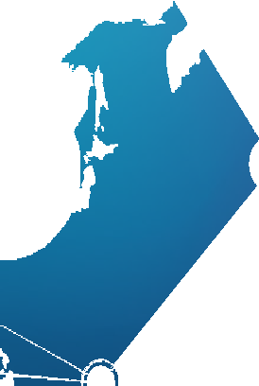
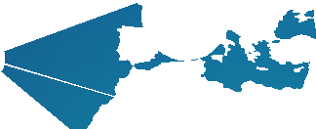
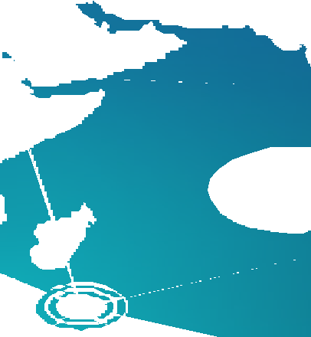
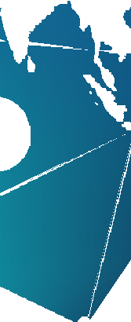
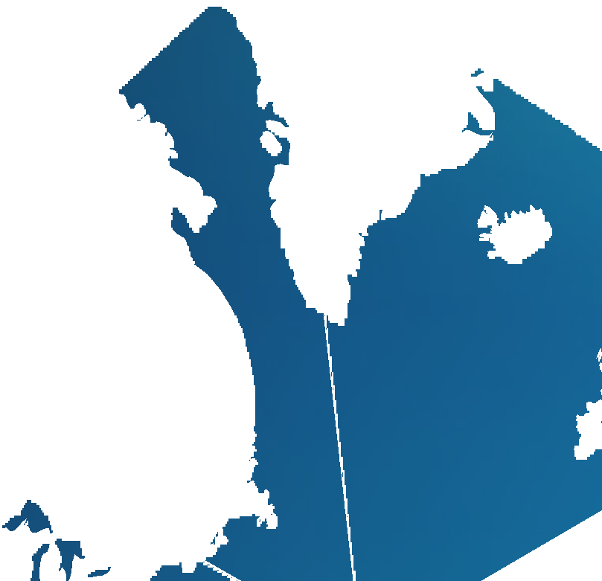
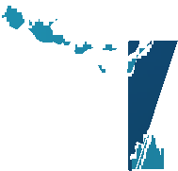
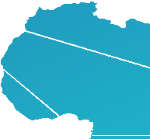
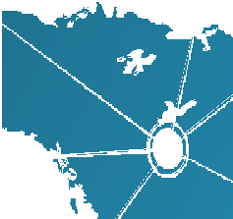
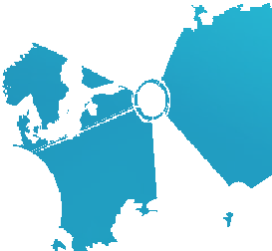
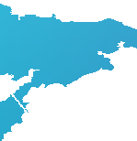
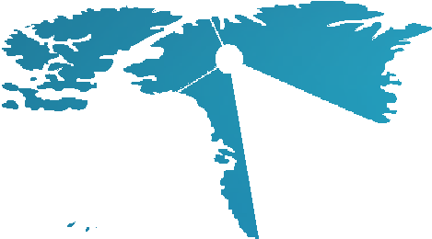
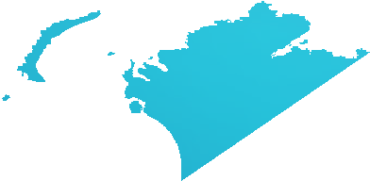

EDGE| Guidebook | Module 3 | Developing and Delivering Your Collaborative Project

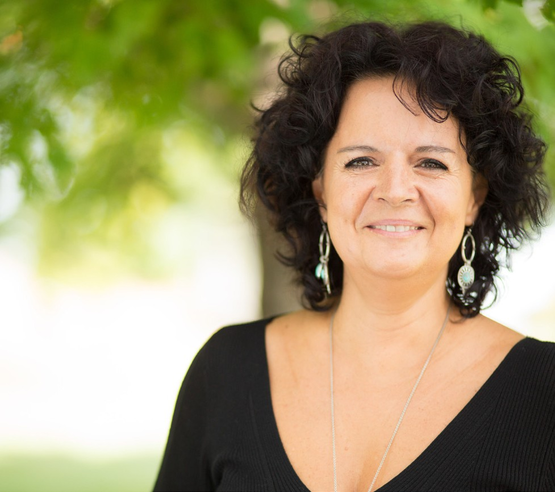
EDGE Learning Outcomes

There are four desirable EDGE Learning Outcomes that will benefit our students both personally and professionally in the 21st century:

- Intercultural interaction
- Project collaboration
- Distance collaboration
- Digital skills

To concretize these outcomes for EDGEd courses, we rec- ommend to our EDGEing faculty that they adapt one or more global learning outcomes (GLO) from the AAC&U global learning rubric to their course, include the GLOs in their syllabus, and then (with their partner) identify an EDGEd ac- tivity that would produce assessable work that would meet that GLO.

Global Learning Rubric
Global learning is a critical analysis of and an engagement with complex, interdependent global systems and legacies (such as natural, physical, social, cultural, economic, and po- litical) and their implications for people’s lives and the earth’s sustainability.

Through global learning, students should:
- Become informed, open-minded, and responsible people who are attentive to diversity across the spectrum of differences.
- Seek to understand how their actions affect both local and global communities.
- Address the world’s most pressing and enduring issues collaboratively and equitably.

The Global Learning Rubric focuses on:

- Global self-awareness
- Perspective taking
- Understanding cultural diversity
- Personal and social responsibility
- Global systems
- Knowledge application

The Global Learning Rubric can be found on page 14 and on the
Association of American Colleges and Universities web site
http://www.aacu.org/value/

Penn State Beaver’s Spring 2018 EDGE Pilot
Professor Claudia Tanaskovic pulled from milestone 2 of the “perspective taking” line of the rubric for the GLO she put into her sylla- bus: “identifies and explains multiple perspec- tives (such as cultural, disciplinary, and ethical when exploring subjects within natural and human systems).”
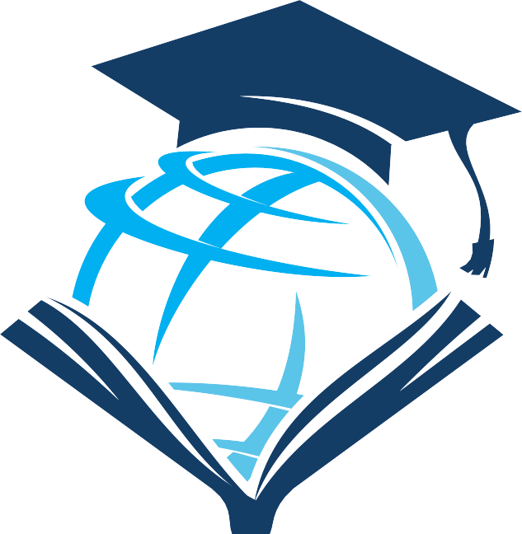
The GLO for her Organic Chemistry class became “Identify the role and impact of the chemical industry in your local region as com- pared to at least one other region of the world.”

EDGE| Guidebook | Module 3
| Developing and Delivering Your Collaborative Project
14

 | Capstone 4 | Milestones  3 2 |  | Benchmark 1
Global Self-Awareness | Effectively addresses significant issues in the natural and human world based on articulating one’s identity in a global context. | Evaluates the global impact of  one’s own and others’ specific local actions on the natural and human world. | Analyzes ways that human ac- tions influence the natural and human world. | Identifies some connections between an  individual’s personal decision-making and certain local and global issues.
Perspective Taking | Evaluates and applies diverse  perspectives to complex subjects within natural and human systems in the face of multiple and even  conflicting positions (i.e. cultural,  disciplinary, and ethical.) | Synthesizes other perspectives  (such as cultural, disciplinary, and ethical) when investigating sub-  jects within natural and human systems. | Identifies and explains multiple perspectives (such as cultural, disciplinary, and ethical) when  exploring subjects within natural and human systems. | Identifies multiple perspectives while main- taining a value preference for own posi-  tioning (such as cultural, disciplinary, and ethical).
Cultural Diversity | Adapts and applies a deep under- standing of multiple worldviews,  experiences, and power structures while initiating meaningful interac- tion with other cultures to address significant global problems. | Analyzes substantial connections between the worldviews, power  structures, and experiences of mul- tiple cultures historically or in con- temporary contexts, incorporating respectful interactions with other  cultures. | Explains and connects two or more cultures historically or in contemporary contexts with  some acknowledgement of power structures, demonstrating re-  spectful interaction with varied  cultures and worldviews. | Describes the experiences of others histor- ically or in contemporary contexts primarily through one cultural perspective, demon-  strating some openness to varied cultures and worldviews.
Personal and Social Responsibility | Takes informed and responsible action to address ethical, social, and environmental challenges in global systems and evaluates the  local and broader consequences of individual and collective interven-  tions. | Analyzes the ethical, social, and en- vironmental consequences of glob- al systems and identifies a range of actions informed by one’s sense of personal and civic responsibility. | Explains the ethical, social, and environmental consequences of local and national decisions on global systems. | Identifies basic ethical dimensions of some local or national decisions that have global impact.
Understanding Global Systems | Uses deep knowledge of the his- toric and contemporary role and differential effects of human or-  ganizations and actions on global systems to develop and advocate for informed, appropriate action to solve complex problems in the hu- man and natural worlds. | Analyzes major elements of global systems, including their historic  and contemporary interconnec-  tions and the differential effects of human organizations and actions, to pose elementary solutions to  complex problems in the human  and natural worlds. | Examines the historical and  contemporary roles, interconnec- tions, and differential effects of  human organizations and actions on global systems within the hu- man and the natural worlds. | Identifies the basic role of some global and local institutions, ideas, and processes in  the human and natural worlds.
Applying Knowledge to Contemporary Global Contexts | Applies knowledge and skills to im- plement sophisticated, appropriate, and workable solutions to address complex global problems using  interdisciplinary perspectives inde- pendently or with others. | Plans and evaluates more complex solutions to global challenges that are appropriate to their contexts  using multiple disciplinary perspec- tives (such as cultural, historical,  and scientific). | Formulates practical yet ele- mentary solutions to global  challenges that use at least two  disciplinary perspectives (such as cultural, historical, and scientific). | Defines global challenges in basic ways,  including a limited number of perspectives and solutions.
Reprinted with permission from “VALUE: Valid Assessment of Learning in Undergraduate Education.” Copyright 2019 by the Association of American Colleges and Universities. http://www.aacu.org/value/index.cfm.

Importance of Student Collaboration vs. Shared Project
For students to gain global competency and intercultural competency, it is important that the project require students to act collaboratively as members of an international team. Helping students learn to work with other students is always challenging, and having them do so with students in different countries may be even more challenging. If we consider that part of our role as educators is to help prepare our students to be ready for global work, this sort of activity can provide an invaluable experience for students from all participating institutions.

Task design is important since many well-intentioned col- laborative activities often end up not being collaborative at all. For example, if students are asked to co-write an essay, what often happens is that they divide the work up so that they are co-dependent, i.e. the final product depends on the various parts, but is not collaborative as each partner individ- ually completes their part. Collaborative tasks must, there- fore, have some degree of inter-dependence, e.g. completion depends on knowledge, information and/or artifacts that only peers have access to and that cannot be found on the Internet. Certainly as you and your partner design the collab- orative task, you will need to keep in mind the global learning objective and its assessment.

Deliverables and Grading
Both partners need to agree on a collaborative project. You do not necessarily need to require the same deliverables nor do you need to use the same grading rubrics for your students, especially if your EDGE course is inter-disciplinary.
While the GLOs may be the same for both courses, the learn- ing objectives and the method you choose to measure the attainment of those learning objectives in each course may differ widely.

Course Module and Lesson Development
At the post-secondary level, having a lesson plan may not always be necessary; however, in an EDGE course, working things out in detail will save you time and streamline the flow of the class. Online teachers know that when facilitating an online discussion, staying on task and being well prepared
is one of the keys to a successful virtual class. Furthermore, module plans can be tweaked and re-used in subsequent semesters and they will ease some of the initial nervousness when you embark on your first few sessions. Having clear lesson plans set out and available to students also helps them navigate the often unknown waters of online intercul- tural communication.

Provide Opportunity for Critical Reflection/ Assessment
Assessment is a large component of any institutional course and needs to be defined up front and made transparent to students. While you and your partner may have different ways or methods of assessing your students, it is important to address these and to be aware of how you both intend
to assess students. Be transparent with your differences in assessment by communicating this with both sets of stu- dents, for you can be certain they will discuss this amongst themselves.

Students may have a lot to say about the experience so pro- vide the opportunity for them to do so while taking care to recognize that direct self-expression may not come easily to some students. This kind of reflection can be supported by weekly journaling or blogging, assigning a written reflection or conducting a virtual meeting at the close of the project to discuss lessons learned. Whatever you decide, critical reflec- tion is an integral aspect to their learning about and engag- ing with the content from a global perspective. The insights that emerge will likely add to your own understanding of the course content and facilitate your assessment of their learn- ing. Given the challenges associated with assessing inter- cultural competence, many educators (see O’Dowd 2010 in Guth & Helm 2010 in Resources) use portfolio assessment by which students reflect on their learning and provide examples (e.g. text from a forum or audio clips from a Skype recording) of how and when this learning took place.

Issues of Technology
Not all colleges use a proprietary Learning Management Sys- tem (LMS), such as Canvas, and if one is being used, partners may have different levels of comfort using it. Also, depending on your and your partner’s colleges’ policies, issues of access to the technology for both sets of students (where one cohort is not registered at the college) and support for those technol- ogies may vary. For this reason, many EDGE courses use free, open-access applications such as Skype, Zoom, and Google Drive, but both partners need to check with their campus IT support to be certain that the tools they plan to use will not be problematic or even blocked.

Another suggestion is that when there is a language imbal- ance, i.e. one group is made up of native speakers and the other foreign language speakers, it may be worth tipping the balance back to the foreign language speakers by using tools with which they are already familiar. In this way one cohort has a linguistic advantage, the other a technological one. Re- gardless, you will both need to determine and agree on what technologies you want to use for communication and collab- oration purposes. Once again, remember that as teachers you are modelling collaborative online international communica- tion for your students.

Test the Technology
Murphy’s Law seems to always surface when technology is involved when teaching, so be prepared. If embarking on a synchronous activity, go online at least 30 minutes
ahead of schedule to make sure things are working as they should, and if at all possible, have someone from your tech support on hand to assist if required. Even if it works during testing, something could always go wrong, so make sure you always have a Plan B. If you will be using solely asyn- chronous communication, check that your assignments, if posted in an LMS for example, are accessible. Check and double-check.

Encourage students to point out problems (e.g. via email to you). Also let students know that you are learning with
and through them. Everybody—teachers, students and tech staff—are doing innovative, challenging things in an EDGE course. Everybody needs to be patient with one another and help out if things don’t go perfectly.

Expect the Unexpected
One of the truly fascinating aspects of Penn State EDGE courses is that the knowledge building that you are about to witness and be a part of will take unknown shape and form. Teachers need to be prepared to let plans take longer than expected if, for example, activities are leading to an interesting discussion or to let plans go if activities aren’t working. Where possible this flexibility can be built into the course syllabus, but constant communication between partner teachers is the only way to guarantee real flexibility.

16

Notes

Preparing Students for EDGE Collaboration

Module 4

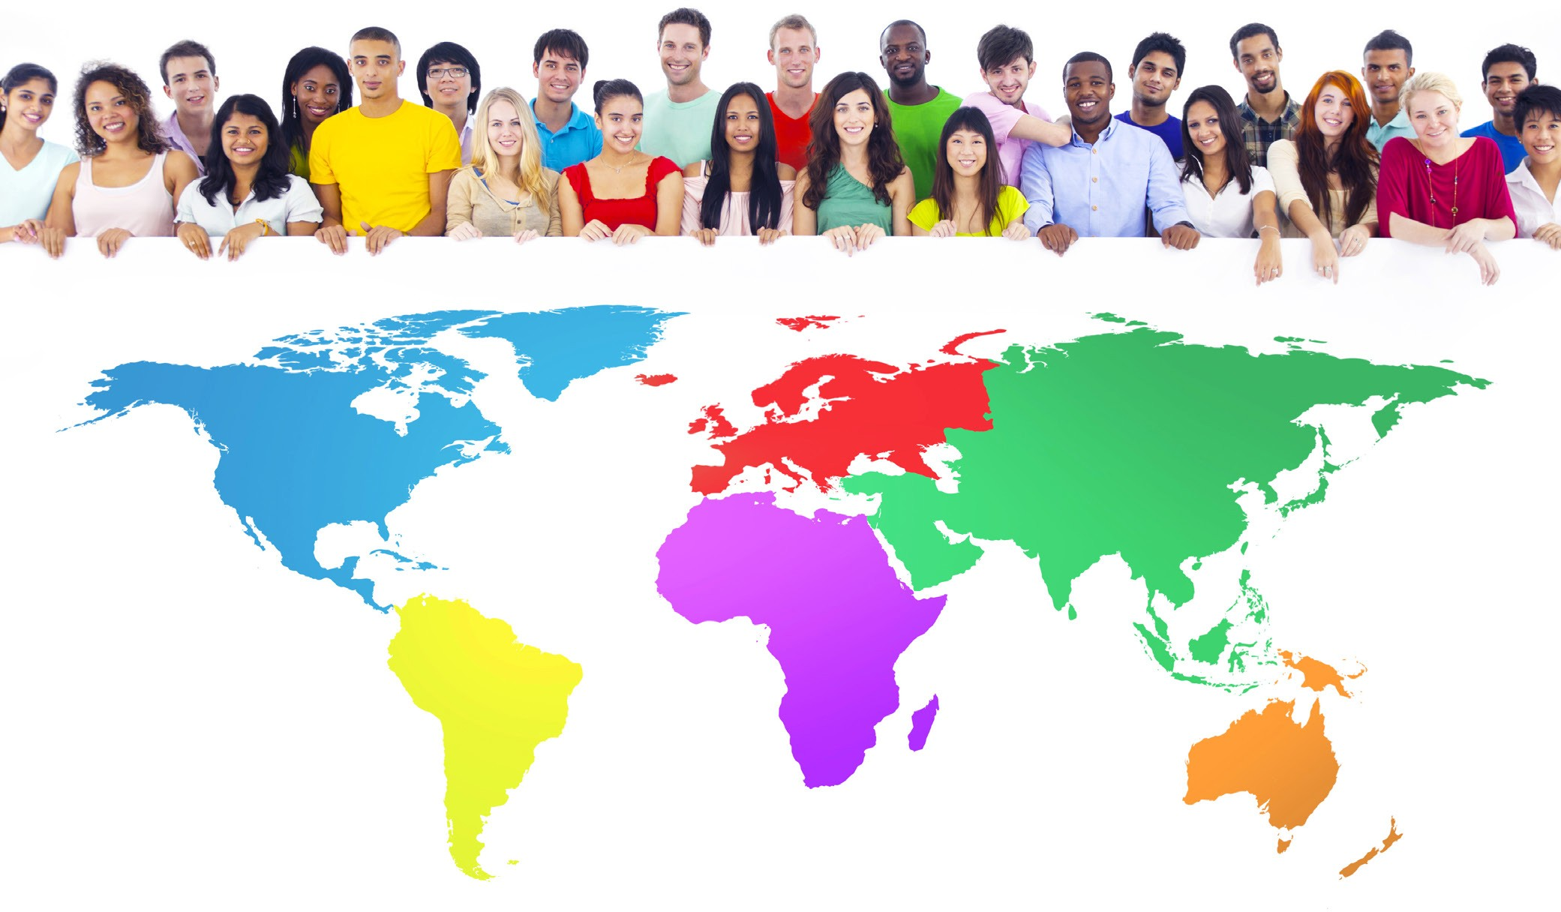

Develop Intercultural Competence
Understanding intercultural communication, upon which EDGE courses are based, is a bit like learning a new lan- guage. Unspoken differences between collaborating students can create challenging moments when material presented is interpreted or responded to in a completely un- expected way. For example, humor and irony can be difficult to understand cross-culturally.

However, these sometimes awkward moments are a normal aspect of intercultural communication and they can provide an opportunity for the discussion and exploration of cultur- al differences that otherwise would go unnoticed. Part of what courses based on the EDGE model do for students is to provide them with the opportunity to challenge their own assumptions about communication, about learning, and about each other. You will want to build this learning into your course syllabus, perhaps by adapting one of the global learning objectives from the AAC&U global rubric to add to your course learning objectives, and determining exactly how you will assess that learning.

We all tend to react instinctively to the world around us and that includes what goes on in our classrooms, but in this situation everyone needs to look twice at many of the
exchanges which take place – before making false assump- tions about the meaning of what we are receiving. This complexity will be part of your learning environment, so it
is especially important that faculty partners make an effort to react sensitively to possible culturally-based misunder- standings between students and even between themselves.

It is important for both teachers and students to be pre- pared for intercultural communication. We recommend teachers explore the literature before the course begins and prepare tasks and readings for students before and at the beginning of the course to raise awareness. Teachers must also learn how to turn awkward moments of misunder- standing into teachable moments. At the end of this guide, we have prepared a series of resources that you can use as a starting point for these discussions.

Cultural Competency
As professors, we strive to nurture our students’ sense of self-efficacy, encourage their curiosity through critical
thinking, and inspire them to embrace the inherent diversity that surrounds us. EDGE allows us to take those principles one step farther, as we create a safe and open learning environment with intercultural partners eager to collaborate, share, and grow.
19

The idea of Cultural Competency is a lofty goal that requires multiple steps to attain. The Center for Disease Control and Prevention (CDC) defines Cultural Competence as “a set
of congruent behaviors, attitudes, and policies that come together in a system, agency, or among professionals that enables effective work in cross-cultural situations.”
Three steps to move toward cultural competence involve cul- tural knowledge, cultural awareness, and cultural sensitivity.
- "Cultural knowledge" means that you know about some cultural characteristics, history, values, beliefs, and behaviors of another ethnic or cultural group.
- "Cultural awareness" is the next stage of understand- ing other groups -- being open to the idea of changing cultural attitudes.
- "Cultural sensitivity" is knowing that differences exist between cultures, but not assigning values to the differ- ences (better or worse, right or wrong).
https://ctb.ku.edu/en/table-of-contents/culture/cultur-
al-competence/culturally-competent-organizations/main

Before your students even begin communicating with their international counterparts and engaging in icebreaker ac- tivities, we need to expose them to the culture and social structure of our partner country, provide them with the tools to explore and be aware of these differences, and lastly, acknowledge any bias or assumptions that may cause them to assign values to these differences.

Undoubtedly, students will come into this EDGE experience with varying levels of exposure and cultural knowledge of their new international partners and their country. What values, beliefs, traditions or customs exist in their region? How did their history help shape those values, beliefs, tradi- tion or customs? What kind of government exists? Is there a monarchy? Are they in a rural or urban area? What does a typical Friday night look like for these students? What’s the most popular food? Students must be armed with a basic knowledge and understanding of their culture to be able to effectively communicate with their partners.

To provide Cultural Knowledge, design a crash course on the culture of your partner country, being certain to include such pop culture aspects as fashion, music, icons, etc.. Ask your students to contribute to the growing body of knowledge as they explore sources and reflect on those findings. The pro- cess of self-reflection will enable students to progress along the continuum to cultural awareness and sensitivity.

Now that your students are armed with a foundation of knowledge about how and possibly why your international partners believe and practice what they do, it is important to recognize the same for your own culture. A self-assessment of your students’ own personal beliefs, attitudes and values is a necessary step to close this loop of discovery and al- lows for Cultural Awareness. One such tool, included in the cross-cultural training workbook Culture Matters, developed by the Peace Corps for their recruits, is the Iceberg Activity. The activity asks users to identify surface traits and how underlying, invisible cultural aspects guide those traits and behaviors. Just as only the tip of the iceberg can be seen
above the water line, so can only the observable behaviors in a culture, but it is important to recognize and acknowledge the rich cultural base of the iceberg that influences its people.
Cultural Sensitivity is when we merge our intercultural knowl- edge base with our self-realization of our own culture and respect the differences without any judgement of value. We move beyond an ethnocentric perspective and embrace the differences.
This journey leads both students and faculty, to a level of Cultural Competency that can have a tremendously positive impact on the intercultural communication, collaboration, and foundation of trust for a rewarding EDGE experience!

Story from the Field
Whenever I am working with an international partner, I devote a great deal of time upfront to design a CANVAS module that explores the culture of my partner country. This module provides my students with the Cultural Knowledge that they need to build their foundation of Cultural Competency. I include information about the country’s history, traditions, government, health- care, weather, education, religion, language, typical foods, popular entertainers, music, etc. I provide links to English versions of their popular news sources and we follow top news stories of interest. Additionally, I include graded discussion boards to en- courage meaningful engagement and students are asked to add new sources to our growing body of knowledge. The students truly seem to enjoy this time of discovery and eases their anxiety of finding common ground during icebreaker activities!
~Assistant Teaching Professor, Samantha Beebe, Penn State Lehigh Valley

Formulate Relationships Using Icebreakers
Your students will likely be as new to this form of learning as you may be, and they may approach the course with some false expectations and apprehensions. Fostering relation- ship-building between students will help you all as a class to grow and engage in the course content. Indeed in Salmon’s widely used 5-step model for online learning (see Resources at the end of the guide), the first step is Access and Motiva- tion (dependent on teachers and tech staff) and the second is Socialization and Familiarization with technology, before Information Exchange. Allowing one to two weeks for pre- paratory tasks that allow students to develop a sense of trust and community as well as to feel comfortable with the
20 technology, leads to a more fruitful exchange.

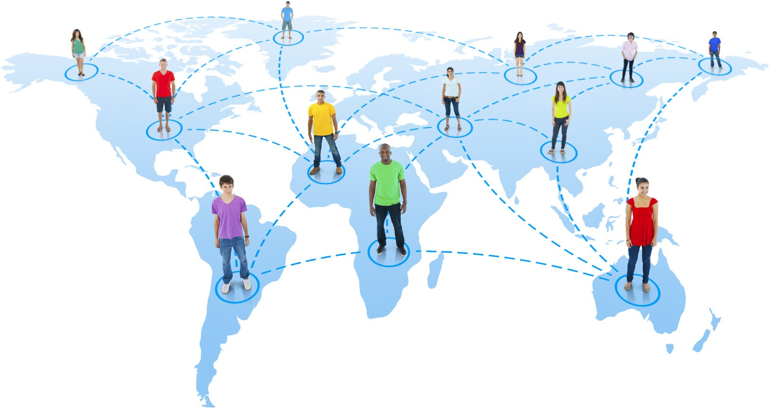
Story from the Field
Regrettably for the first two EDGE projects, my faculty partners and I did not allot much time for icebreakers beyond the tra- ditional “tell us about yourself” prompt in a joint Zoom videoconference. In the one course, I extended the icebreaker a bit by requiring students to create a presentation of pictures while telling their partners about their institution. The students found the content interesting, but it really did not lend itself to increased communication between international group members. The feedback from students supported this concern and made it clear that too much time was focused only on the project deliver- able.

For my third EDGE collaboration, we asked students to address the following prompts:

- name/nickname and major
- place of birth and nationality
- photo or two of yourself
- short description of likes and dislikes, interests and activities or hobbies
- Response to the following statement: You may be surprised to know… (You can share something that your peers may find surprising about yourself, your school, your course study, your culture, or your country.)

They were then asked to end their post by posing a question to be answered by your other group members (Examples: To where would you like to travel?) and comment on the post of two international peers. It was interesting to read their responses to each other, and I found that some students posted more than the required two responses…yay, communication.

We then assigned a video project intended to provide additional information about their College/University. Student interna- tional teams had to agree on two themes (classrooms, professors, housing, class schedule, food, activities, etc.) and each film content focusing on their selected themes. The international teams then had to create one video that told the story of “A Day in the Life of…” from their team’s perspective. Since their final EDGE collaborative project is also a media assignment, this project gave them experience collaborating, delegating, compiling, filming, and editing before their final deliverable.

All of their communication was required to take place in Slack, and it was thrilling to witness the relationships form in the pro- cess: students commenting to each other about their observable similarities and cultural differences. Some students posted photos or video of their group members just saying “hi” to their international group members in the midst of their informal communication.

Much of the value of these EDGE collaborations lies in the interpersonal intercultural communication that often falls outside the boundaries of the project. Icebreakers take time and planning, and it is often tempting to focus primarily on the “delivera- ble.” I have found that the icebreakers are a critical ingredient in student learning.

~Assistant Teaching Professor of English Tiffany MacQuarrie, Penn State Beaver

Gaining Student Buy-In
When offering an EDGE project, it is important that you win student buy-in. In other words, it is important that you “sell” the importance of this project to your students.

Some of the benefits of working on an EDGE project are that it gives your students international experience (working with students who speak a different language and are from a different country and culture). In addition, since EDGE is project based, your students will gain experience in project
management. Students will learn how to plan, lead, organize and control a project (PLOC), as well as communicate and collaborate with project partners.

Working on an EDGE project also gives your students valua- ble work experience, which is easily translated into interna- tional consulting and project management experience on a student’s resume. In essence, an EDGE project gives stu- dents unique international work experience (something not available to all college graduates), a skill that is looked upon very favorably by employers.

A Penn State EDGE project is fun and unique. It offers mean- ingful work experience and enables Penn State students to differentiate themselves from other college graduates in the competitive employment marketplace.

Story from the Field
In the fall of 2017, I developed a pre-pilot EDGE project with The Hague University of Applied Sciences (THUAS) for my BA 421 Project Management class. In this project, teams from Penn State Beaver and THUAS examined the admis- sions process between the two schools’. Acting as consult- ants, students from each school prepared various project deliverables: a project work plan, business process flow diagram, technology assessment analysis, SWOT (strengths, weaknesses, opportunities, threats) analysis, and an assess- ment of each schools admissions department based on
a capability maturity model. As final project deliverables, students prepared a written report and gave a final project presentation. Students performed the project in three weeks, while actual pre-project planning took approximately nine weeks.

Penn State Beaver students enjoyed working with fellow students from another country, gained valuable work experi- ence, learned about the Dutch culture, and made important international business connections. As an interesting side note, students “Facebooked” each other within minutes of being assigned to their international project teams, suggest- ing that students focused first on social relationships and communication before engaging in business relationships and communication.

~Associate Professor of Business, Daniel W. Smith, Penn State Beaver

Notes

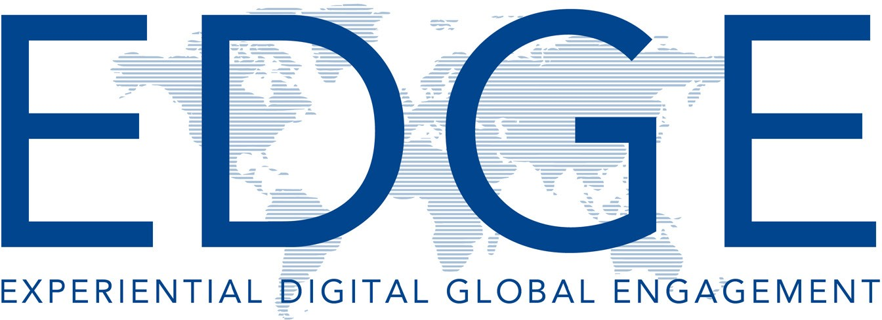
Resourсes

Web Books Conferences

AAC&U
Association of American Colleges & Universities
Global Learning Rubric https://www.aacu.org/

ACE-American Council on Education Offers programs and services that enhance internationalization on U.S. campuses
https://www.acenet.edu/

EDGE-Penn State University Experiential Digital Global Engagement https://sites.psu.edu/edge/

Global Learning Hub-UC Davis https://globallearning.ucdavis.edu/ pathways/experience/community/ virtual

IIE-Institute for International Education
Develops and implements many of the world’s most prestigious and innovative scholarship and training programs, including supporting the flagship educational and cultural ex- change programs of the U.S. Depart- ments of State and Defense. https://www.iie.org/

Steven’s Initiative
Virtual exchange community through cross-cultural experiences. https://www.stevensinitiative.org/
Building Cultural Competence: Innovative Activities and Models A cutting-edge framework and an innovative collection of ready-to-
use tools and activities to help build cultural competence.
Kate Berado & Darla K. Deardorf

Making Global Learning Universal: Promoting Inclusion Succes for All Students
Offers a model to make global learn- ing universal along with providing
a definition of global learning that incorporates diversity, collaboration, and problem solving as essential components.
Hilary Landorf, Stephanie Doscher, Jaf- fus Hardrick & Caryn McTighe Musil

The Culture Map: Breaking Through the Invisble Boundaries of Global Business
A field-tested model for decoding how cultural differences impact international business, and combines an analytical framework.
Erin Meyer

AACE Global Learn Conference Global networks, partnerships, and exchanges, research, assessments, learning and technology along with educational policy, reform, and inno- vation.
https://www.aace.org/

CIES-Comparative & International Education Society
Conferences, publications, and pro- fessional network. https://www.cies.us/

Diversity Abroad Conference
A comprehensive national forum on issues of access, diversity, equity, and inclusion in global education. https://www.diversitynetwork.org/

IVEC-International Virtual Exchange Conference https://iveconference.org/

AIEA-Association of International Education Administration https://www.aieaworld.org/

Diversity Abroad Conference https://conference.diversitynetwork. org/

International Perspectives on University Teaching and Learning http://www.auburn.edu/academic/ international/iputl/2020/index.php

